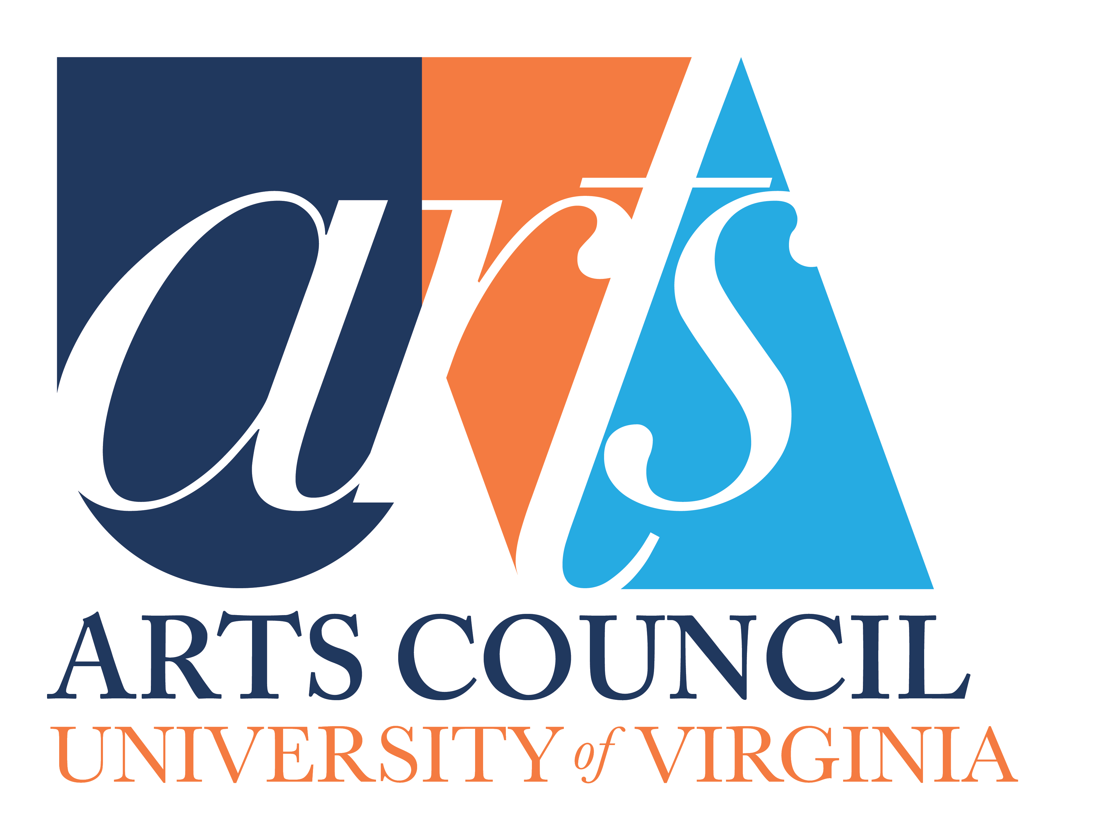
UVA Arts Council
Grant Proposal Instructions

1.Applicant Guidelines: Please review in full (attached/link).

2.Grant Proposal Form (attached/link) fill out fully in order for your submission for an
Arts Council grant to be considered. (Please submit as WORD document).
- The proposal form seeks brief summaries in each category. There is an option to attach additional material in support of a proposal.
- As stated in our Goals, the impact of any given project takes into account not only the number of participants or audience, but also considers the nature, breadth and depth of the project. A project may have a broad impact on many students or community members and/or a deeper impact on fewer people.
- If your school, department or program received an Arts Council grant last year, you will also need to include the Arts Council Grant Report (attached/link).

3. Detailed Description
- Applicants are welcome to attach a more detailed description, up to two additional pages of the project, including any letters of support from colleagues, and any supporting photos or documents or links to information about artists or organizations involved in the proposed project.
- These additional, fuller descriptions will be reviewed by the Grants Committee.

4. Arts Council Budget Form (attached/link)
If the grant proposal requests that UVA Arts Council provide 20% or more of the funds for a project, please fill in this budget form. (We also welcome budgets, if available, for which UVA Arts Council would be funding less than 20% of the budget).
- Fiscal Year: The funding requested needs to be for projects to be started and completed within the next fiscal year.
- Instructions: You can fill out this form on your computer and insert extra rows in each section as needed. Dollar amounts in each category will automatically summate. Once you have completed the budget, please save in EXCEL to submit with your grant proposal. Thank you.
- Two purposes
1. To give grant applicants some insight into the types of projects and aspects of projects that the UVA Arts Council considers for funding.
2.To clarify for the Arts Council where the funds will be used.
Although we welcome itemized amounts we understand that those amounts may not be available in all categories at the time the grant proposal is submitted. We are looking for best estimates, and some categories may not apply to your proposal.
- There is a category for "Other" and “In-Kind” items that may be unique to your project.

5. Grant Report Form (attached/link)
- By accepting Arts Council funds, you agree to provide the Arts Council, via the Vice Provost for the Arts office, with an Arts Council Grant Report prior to submitting a new grant request or directly following the completion of your project, if it extends past the Arts Council Grant Proposal Deadline.
- If your department or program received an Arts Council grant the previous year, you will also need to include the Arts Council Grant Report. Applications submitted without Arts Council Grant Report (if required) will not be considered for continued support in the upcoming cycle.
- This grant report is an opportunity for grantees to highlight the successes of a given project with photos, impact or testimonials, links and an indication of level of participation of students and the greater UVA and surrounding community, as well as how the Arts Council was acknowledged.
- Additional Description
  - Applicants are asked to attach additional information of up to three photos or provide links that illustrate the highlights of the project/events.
  - Applicants are welcome to attach a more detailed description, up to two additional pages, of the project, including photos or documents or links to information about artists or organizations involved in the project.
- The information provided in the Grant Report is the basis for an inspirational PowerPoint presentation for the full UVA Arts Council at the annual Spring Art Council meeting that highlights the impact of the funded projects on the Arts at UVA.

