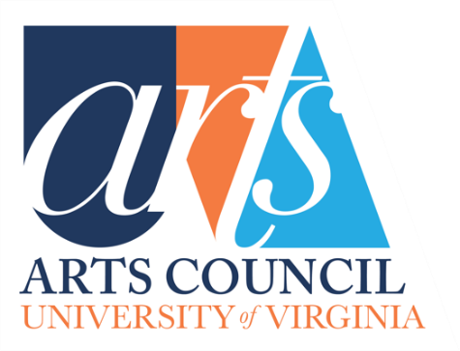
Guidelines for UVA Arts Council
Grants Committee and Applicants

Guidelines for Grant Applicants - Contents

- Goals of the UVA Arts Council Grants Committee
- Values
- Guidelines for Grant Applicants
- General
- Requirements of Applicants and Grant Recipients
  - Application Deadline
  - Proposal Form
  - Budget Form: Must accompany the proposal
  - Grant Report Form
- What is Funded and What is Not Funded
- Grant Administration
- When Project cannot be Done as proposed and approved
- Acknowledging the Arts Council
- Appendix
  - UVA Arts Council Logos
  - Arts Council Grant Proposal Form
  - Budget Form
  - Arts Council Grant Report
Guidelines for Grant Applicants

Goals of the UVA Arts Council Grants Committee

- Promote and increase the visibility and influence of the Arts at UVA.
- Promote direct impact on and higher participation of UVA undergraduates in the arts at UVA, in both breadth and depth.
- Encourage innovation in the arts at UVA.
- Support established ongoing arts programs that promote the Arts Council and that have high participation and visibility of the Arts at UVA and beyond.
- Promote visibility and engagement of arts at UVA in the university community at large, in the wider community, regionally, nationally, and internationally.
- Highlight the commitment and high quality of the arts at UVA and the students at UVA to the wider performing and fine arts communities and professionals outside UVA.
- Offer opportunities for professionals in arts-related fields outside of UVA to experience the strong commitment and high quality of the arts at UVA and the students at the University.
Values: The Grants Committee statement of values promotes the Arts Council’s Mission and Goals and expresses the general criteria and priorities that guide the grants decisions.

- High impact: Maximize participation and impact in both breadth and depth, on students and overall community participation in the arts at UVA within one year
- Focus on Undergraduate experience, enrichment and participation in the arts at UVA.
- Innovation: Pilot projects; trial initiatives, start-up, and early-stage endeavors.
- Provide multiple formats or levels of impact (online platforms, forums, venues) for participation in the arts by students, community members and guest participants (some combination of artists’ residencies, master classes, concerts, lectures, readings, performances…).
- Outside influences: Guest Residencies/visiting guests, by recognized professionals and artists brought to UVA where they can have high student and community impact as well as experiencing the quality of the arts and the students at UVA.
- High Visibility at UVA: Projects that bring high visibility to the arts at UVA.
- High Visibility Beyond UVA: Projects that bring high visibility/recognition to the Arts beyond UVA.

Guidelines for Grants Applicants

General

- Funding amounts: UVA Arts Council grants may be offered up to $10,000.

- Proposals: Proposals should be for projects that are specific and substantive, and should explain the project’s impact on students, as well as, if applicable, its impact on the UVA community at large, the wider community in Charlottesville, and beyond.

- Review the Goals and Values/Criteria of the Grants Committee, above. Your proposal does not need to meet every goal and value to be considered for funding, but the goals and descriptions presented in each proposal should bear some relationship to the Committee’s goals and values. The Grants Committee highly values undergraduate impact.
- Number of Proposal per Department: Each eligible department or program may submit up to two Grant Proposals for consideration.

Requirements of Applicants and Grant Recipients

Application Deadline: Applications for grants should be received by the posted deadline. This includes the Proposal Form, the Budget Form, the Grant Report Form (if applicable) and the optional additional Detailed Description.

Proposal Form
- The proposal form seeks brief summaries in each category. There is an option to attach additional material in support of a proposal.
- The Arts Council Grant Proposal form (attached/link) needs to be filled out fully in order for a submission for an Arts Council grant to be considered along with a completed Arts Council Grant Report form (attached/link) if your department or program received an Arts Council grant the previous year.
- Additional Detailed Description:
- Applicants are welcomed and encouraged to attach a more detailed description, up to two additional pages of the project, including any letters of support from colleagues, and any supporting photos or documents or links to information about artists or organizations involved in the proposed project.
- WORD Format: Please submit the Proposal Form in WORD format.

Budget Form

- The UVA Arts Council Budget Form must accompany the proposal (attachment/link). If the Grant Proposal requests that UVA Arts Council provide 20% or more of the funds for a proposal, please fill in this Budget Form with your best estimates. (We also welcome budgets, if available, for which UVA Arts Council would be funding less than 20% of the budget, but this is not required).
- Purpose of Budget Form

- To give grant applicants some insight into the types of projects and aspects of projects that the UVA Arts Council considers for funding.
- To clarify for the Arts Council where the funds will be used. Although we welcome itemized amounts, we understand that those amounts may not be available in all categories at the time the grant proposal is submitted. We are looking for best estimates, and some categories may not apply to your proposal. There is a category for "Other" and “In-Kind” items that may be unique to your project.
- EXCEL Format: Please submit the Budget Form as an EXCEL document.

Grant Report Form

- By accepting Arts Council funds, you agree to provide the Arts Council, via the Vice Provost for the Arts office, with an Arts Council Grant Report prior to submitting a new grant request or directly following the completion of your project, if it extends past the Arts Council Grant Proposal Deadline.
- If your department or program received an Arts Council grant the previous year, you will also need to include the Arts Council Grant Report (attached/link) with your Proposal Form. Applications submitted without Arts Council Grant Report (if required) will not be considered for continued support in the upcoming cycle.
- The Grant Report Form is an opportunity for grantees to highlight the successes of a given project with photos, impact or testimonials, links and an indication of level of participation of students and the greater UVA and surrounding community, as well as how the Arts Council was acknowledged.
- Additional Description
  - Applicants are asked to attach additional information of up to three photos or provide links that illustrate the highlights of the project/events.
  - Applicants are welcome to attach a more detailed description, up to two additional pages, of the project, including photos or documents or links to information about artists or organizations involved in the project.
- The information provided in the Grant Report is the basis for an inspirational PowerPoint presentation for the full UVA Arts Council at the annual Spring Art Council meeting that highlights the impact of the funded projects on the Arts at UVA.

What is Funded and What is Not Funded
- Please look over the UVA Arts Council Budget Form for the funding categories.
- Note that the funding requested needs to be for projects to be started and completed within the next fiscal year.
- As stated in our Goals, the impact of any given project takes into account not only the number of participants or audience, but also considers the nature, breadth and depth of the project. A project may have a broad impact on many students and community members and/or a deeper impact on fewer people.

- Funding amounts: UVA Arts Council grants may be offered up to $10,000.

- When Grant monies are awarded
- Funding decisions are dependent upon the monies available in a given year. Lower ranked but approved proposals for which funds are not immediately available may be funded later in the year if monies become available by June 30th. Any money collected after that goes to the next granting cycle.
- Please note that the Arts Council Annual Fund Grants are not to be considered part of any department’s budget. Projects that are successful and have been funded for consecutive years may be encouraged to also seek other more predictable funding.

- Length of Grants-Timeline Guidelines
  - We do fund projects for a single year timeline. Grant applications should be made for projects to be completed in one year.
  - We do not fund multi-year timelines where subsequent year budgets are unknown.
  - We do not fund projects within the fiscal year that the proposal is submitted.
- Travel Funding Guidelines
  - We give preference to bringing experts in their arts-related field to UVA where they can have high student and community impact.
  - We are less likely to fund sending a small group from UVA to another location, but this can vary based on the project.
- Formats: We are open to a variety of formats that impact the arts at UVA. This list is only a guide and the formats considered are not limited to this list.

  - We do consider funding performances and exhibitions through visual art, music, dance, drama, media arts, architecture, or multi-disciplinary arts.
  - If the proposal is for recording performances or exhibitions, please explain how the recording will be used and made available.
  - We do consider funding conferences or panels or lectures or classes that engage students and community.
  - We do consider funding projects and programs using emerging technology in the arts with online presence, including content and accessibility to students and beyond.
  - If the location or venue is off Grounds, please explain how students will have access.

- Equipment/“Bricks & Mortar” type proposals
  - We do fund capital expenses tied to other objectives (tied to objectives that expand access or programs).
  - We will take equipment needs into consideration contingent on immediate needs or impact on students. All equipment funded remains the property of the University of Virginia.
  - We do not fund straightforward capital improvements.

- Compensation/wages/Honorariums/ Speakers’ fees
  - We do fund guests such as Artists-in-Residence and Speakers Fees
  - We do not fund salaries for existing positions due to budget issues or new positions denied in University budgeting process.

Grant Administration
Please contact Emma Terry, Programs & Communication Director for UVA Arts, with any questions at emma@virginia.edu .

When Project cannot be done as proposed and approved
If a project cannot be carried out or completed or needs to be modified or did not receive funds from other sources as expected, it is the responsibility of the department to contact the UVA Arts Administration Staff so that appropriate steps can be taken for approval of modifications by the Council or for return of funds.
- Modifying a Grant after Approval: If a project cannot be done as proposed and approved, the Committee will accept formal proposals to modify or clarify any changes and will consider approving funding for the project as modified.
- Return of Grant Funds: If the project cannot be started or only partially completed as approved, and modification is not possible, funds need to be returned.
- No carry-over of funds: Grant funds cannot be carried over until the next year. Rather the funds must be returned, and a grant proposal resubmitted for the next academic year.

Acknowledging The Arts Council
- Include Logo: Please be sure to include the Arts Council logo in your publications (whatever the media) related to any Art Council funded projects (copy from below or contact Emma Terry for a higher-resolution or black & white.) Logo images provided at the end of this document. (See appendix for logo images).

- Printed Materials: The Arts Council contribution should be recognized in any printed materials (programs, CD liner notes, exhibition posters, etc.) resulting from grants.
- Crediting the Arts Council: Please identify where the Arts Council will be credited throughout the project or at events funded in-part.
  - Wholly Funded Projects: For projects wholly supported by an Arts Council grant, the phrase underwritten by the University of Virginia Arts Council is suggested.
  - Partially Funded Projects: For partial funding, use the phrase supported by the University of Virginia Arts Council.

- Project Updates: Grant recipients are encouraged to send updates throughout the academic year highlighting events related to the projects in the form of videos, photos, testimonials from participants, promotional materials, etc.

- Grant Reports: Please include examples of materials related to the grant that included the Arts Council logo and acknowledging phases.
  - The Grant Report is an opportunity to highlight the successes of a given project with photos, impact and testimonials, links and indication of level of participation of students and the greater UVA and surrounding community,
  - The information provided in the Grant Report is the basis for an inspirational PowerPoint presentation for the full UVA Arts Council at the annual Spring Art Council meeting that highlights the impact of the funded projects on the Arts at UVA.
Appendix #1: UVA Arts Logo Images

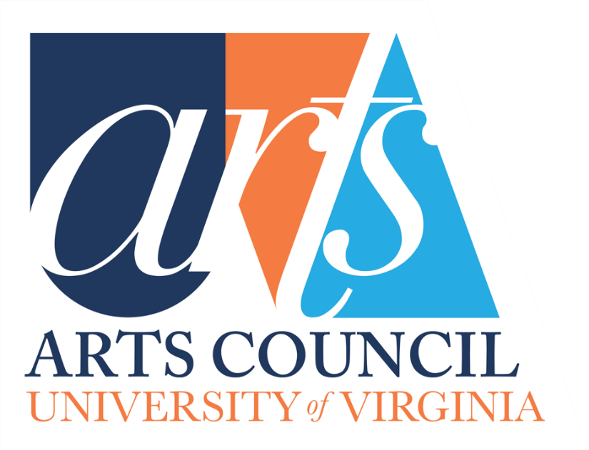

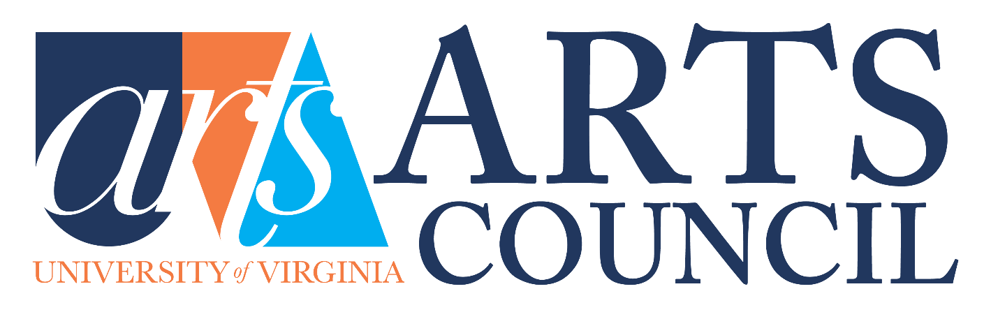

Appendix #2: UVA Arts Council Grant Proposal Form

Appendix #3: Budget Form

Appendix #4: Arts Council Grant Report Form

