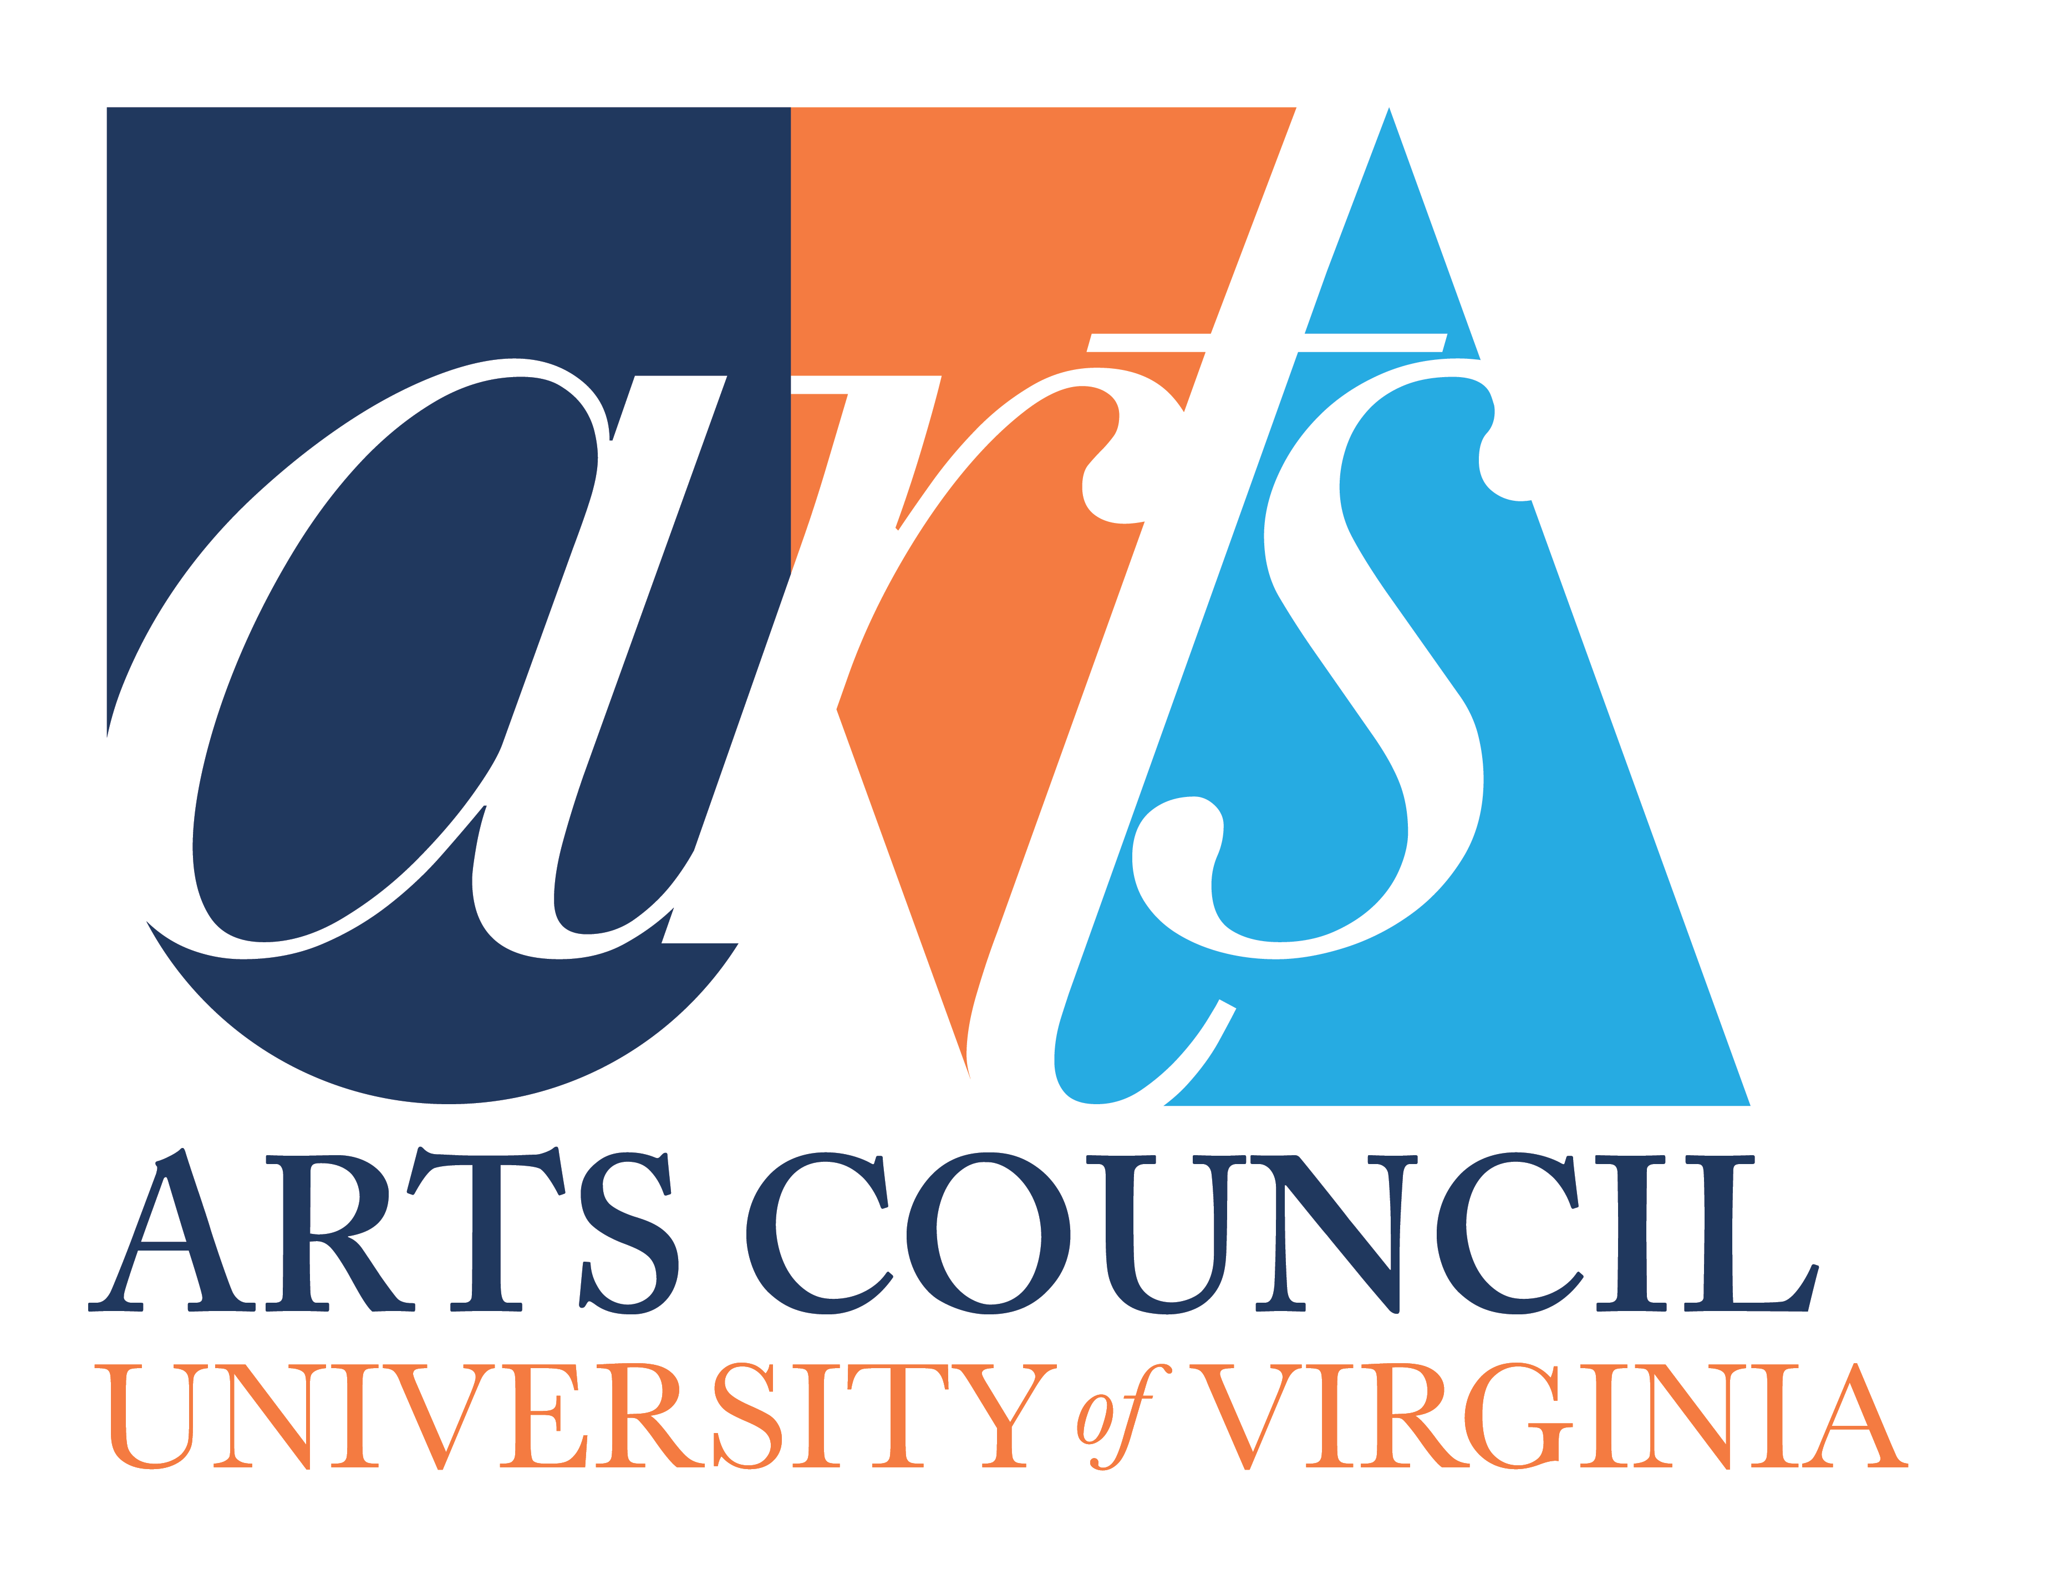
Arts Council Grant Proposal Form

Academic Year: ___ ______________

This form must be filled out fully in order for your submission for an Arts Council Grant to be considered. Also complete the Budget Proposal Form and the Grant Report Form, if you received funds from the Arts Council last year. Please return this form in a WORD format (not a PDF) - Thank you.

Table cells will expand
Department
Date
Contact Name & Title
Contact Email
Department
Title
Type of Proposal (publication, performance, artist-in-residence, exhibition…)
Project Dates(s)
Venue: If the location or venue is off-grounds, please explain how students will have access
Brief Description
(120 word limit): Two-page detailed project description can be attached
Total Cost of Project
Requested of Arts Council
Other Sources of Funding | Confirmed:  Pending:
Budget (please attach)
Impact for Undergraduate Students and Community: (120-word limit) *
Impact Beyond UVA
(120-word limit)
Impacts linked to Arts Council Values
(120-word limit)
How will the Arts Council be acknowledged?
In the event you are a grant recipient please provide information for disbursement of the award:
☐ Via a Rector and Visitors Account: UVA Worktags GIFT ACCOUNTS ONLY:
☐ Via UVA Fund Account #
☐ Via paper check:
Payee Name:

☐ Pick up at Alumni Hall
☐ Messenger Mail to PO Box:
☐ USPS Mail – Address:

* As stated in our Goals, the impact of any given project takes into account not only the number of participants or audience, but also considers the nature, breadth and depth of the project. A project may have a broad impact on many students and community members and/or a deeper impact on fewer people.

